**AIM:** Write a C program to arrange a series of numbers using Quick Sort

**ALGORITHM:**

• Choose a pivot element (commonly the last element of the array).

• Partition the array into two parts:

* Elements smaller than or equal to pivot on the left.
* Elements greater than pivot on the right.

• Place the pivot element in its correct position.

• Recursively apply the same steps to the left and right subarrays until the array is fully sorted.

**CODE:**

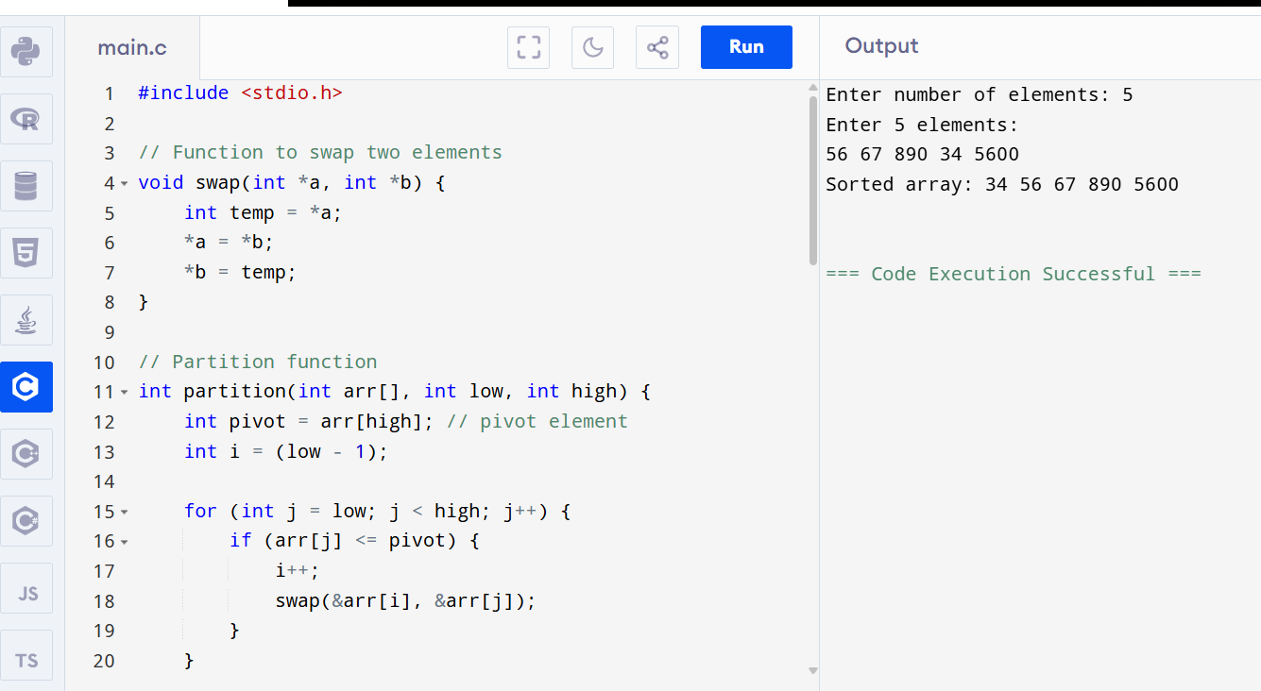

**OUTPUT:**

Enter number of elements: 5

Enter 5 elements:

56 67 890 34 5600

Sorted array: 34 56 67 890 5600